ENHANCEMENT
Option B: Early Warning System (Medium-Hard)
- Identify loans showing early delinquency signals
- Score loans based on: payment behavior, contact success, DPD trends
- Generate daily priority call lists
- Flag accounts needing immediate attention

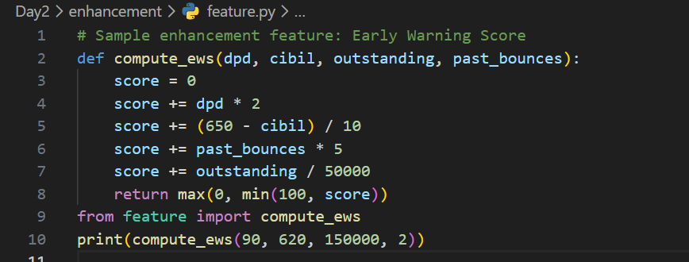

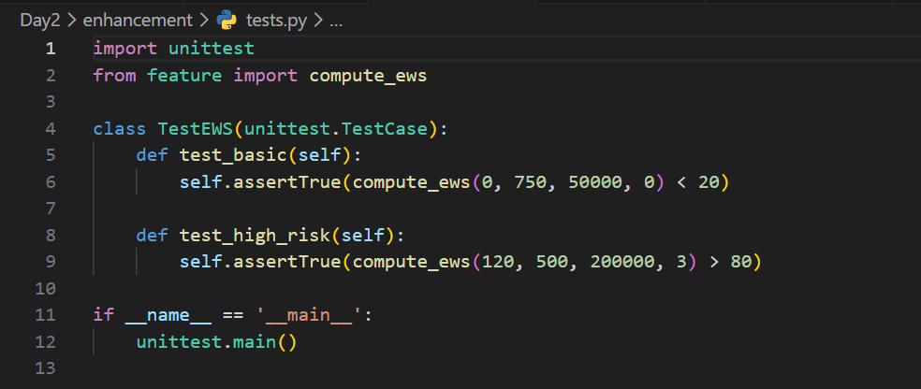

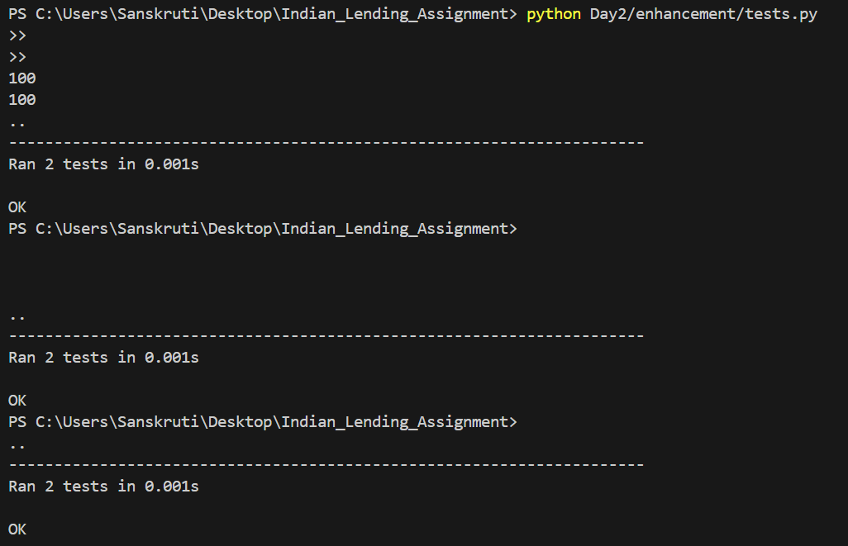

Field Officer User Guide – Text-to-SQL System
(For Collection Officers & Branch Staff)

1. What is Text-to-SQL and Why Use It?
Text-to-SQL is a tool that allows you to ask questions in simple English like “Show me NPA loans” or “Which borrowers missed EMI?” and the system automatically converts your question into a database query and shows the results.

Why it matters for NBFC / Lending Operations
- You don’t need to know SQL or technical skills
- Helps you get loan, borrower, and collection information instantly
- Saves time during daily field visits, branch reviews, and collections huddles
- Ensures consistency in reporting (follows Indian lending rules: DPD, SMA, NPA, CIBIL)
- Reduces dependency on analysts or backend staff

2. How to Ask Effective Questions (Indian Context)
Keep these points in mind:

✔ Keep questions short and clear
Good:
- “Show loans with dpd > 90”
- “Borrowers in Pune branch with CIBIL < 650”
Avoid long sentences like:
- “Please give me all the details of all those customers who have not paid for many days…”

✔ Use common keywords
- loan_id, borrower name, branch, dpd, cibil, outstanding, payment history, agent, ptp

✔ Use filters
Examples:
- By city → “Hyderabad borrowers with dpd > 30”
- By branch → “Mumbai branch NPA accounts”
- By product → “Gold loan customers with overdue > 50,000”

✔ Hinglish-friendly phrasing (future-ready)
System prefers English today. But simple Hinglish keywords also work when clear:
- “dpd list”
- “90+ loans”
- “CIBIL below 600”

3. Example Queries for Common Scenarios

A. Finding Loan Information
- “Show all loans for borrower ID 12”
- “Gold loans with outstanding > 1 lakh”
- “Loans disbursed in Karnataka”

B. Checking Payment History
- “Show payment history for loan_id 101”
- “Payments collected by agent 3 this month”
- “Total payments in last 90 days”

C. Reviewing Communication Logs
If your system stores contact details (PTP, field visits):
- “Show communication log for borrower 5”
- “PTP accounts from last week”
- “Field visit required accounts with dpd > 60”

D. Identifying High-Priority Accounts
Use these for morning huddles or field visits:
- “NPA accounts ordered by outstanding amount”
- “SMA-2 loans in Delhi branch”
- “Top 20 overdue accounts by dpd”
- “Borrowers with dpd > 30 AND cibil < 650”
These queries help you prioritise your calls and visits.

E. Portfolio Quality Checks
Useful for branch managers or team leads:
- “Show bucket-wise distribution of loans”
- “DPD summary by branch”
- “Outstanding amount by product type”
- “How many loans are in NPA?”
- “SMA-1 and SMA-2 counts for this month”

4. Indian Lending Terminology Explained (Simple Definitions)
Term | Meaning
DPD | Days Past Due – number of days borrower has missed EMI
SMA-0 / SMA-1 / SMA-2 | Early-warning RBI categories (1–30 / 31–60 / 61–90 days overdue)
NPA | Non-Performing Asset (loan overdue 90+ days)
CIBIL Score | Borrower's credit score (300–900)
PTP | Promise To Pay – borrower commits payment date
Outstanding | Remaining loan amount
Bucket | Overdue category (B1, B2, B3, NPA)
Bounce | EMI auto-debit failed
Collection Agent | Staff assigned to collect EMIs
Field Visit (FV) | Physical visit to borrower location

5. Troubleshooting Tips

❗ “No results found”
- Check if your filters are too strict
- Try removing one filter (e.g., date range)

❗ “Too many results”
- Add LIMIT 20
- Add filters like branch, loan_type, dpd

❗ “Query not understood”
Rewrite in simple English:
- Instead of: “Give me defaulters list”
Use: “Show loans with dpd > 90”

❗ “Incorrect values”
- Confirm database is updated
- Rerun “SELECT COUNT(*) FROM loans;”

6. Frequently Asked Questions (FAQ)

Q1. Do I need to know SQL?
No. Simple English questions are enough.

Q2. Can I ask questions in Hindi/Hinglish?
Basic Hinglish sometimes works, but English keywords are safest.

Q3. Can I export data?
Yes, many queries support exporting results to CSV.

Q4. Are legal cases included?
You can ask:
- “Show SARFAESI notices”
- “Loans under legal action”

Q5. Is borrower personal data safe?
Yes. The system only shows what you are permitted to view. Sensitive PII is protected.

Q6. Can this replace MIS team tasks?
Not fully. It supports quick queries, but scheduled reports still require MIS involvement.

7. Final Advice for Field Teams
- Check DPD first → tells urgency
- Check CIBIL → tells long-term risk
- Check Outstanding → tells recovery value
- Use queries to plan your daily visit list
- Update communication logs after each call/visit

